**PLUGGING INTO AN FUTURE : AN EXPLORATION OF ELECTRICITY CONSUMPTION PATTERNS**

# INTRODUCTION

India is the world’s third largest producer and third largest consumer of electricity . The national electric grid in India has an installed capacity of 370.106 GW as of 31 March 2020 . Renewable power plants , which also include large hydroelectric plants , constitute 35.86% of India’s total installed capacity. In 2015 – 16 electric energy consumption in agriculture was recorded as being the highest (17.89%) worldwide . The per capita electricity consumption is low compared to most countries despite India having a low electricity tariff.

In light of the recent COVID-19 situation, when everyone has been under lockdown for the months of March to June the impacts of the lockdown on economic activities have been faced by every sector in a positive or a negative way . The dataset is exhaustive in its demonstration of energy consumption state wise. Analysing Electricity Consumption in India from Jan 2019 till 5th December 2020. This dataset contains a record of Electricity consumption in each states of India , here we are going to analyse State wise ,Region wise and Overall Electricity consumption in India.

2.PROBLEM DEFINITION AND DESIGN THINKING

# EMPATHY MAP

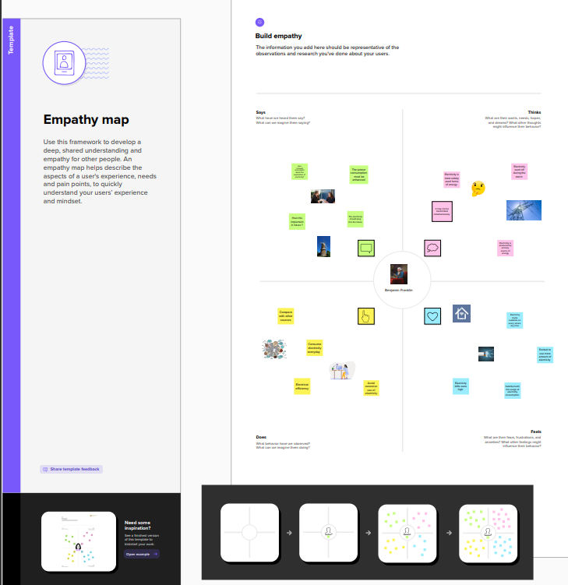

# IDEATION AND BRAINSTROMING MAP

# 

# 

# 

# 

# 3.RESULT

# DASHBOARD 1

# 

# DASHBOARD 2

# 

# DASHBOARD 3

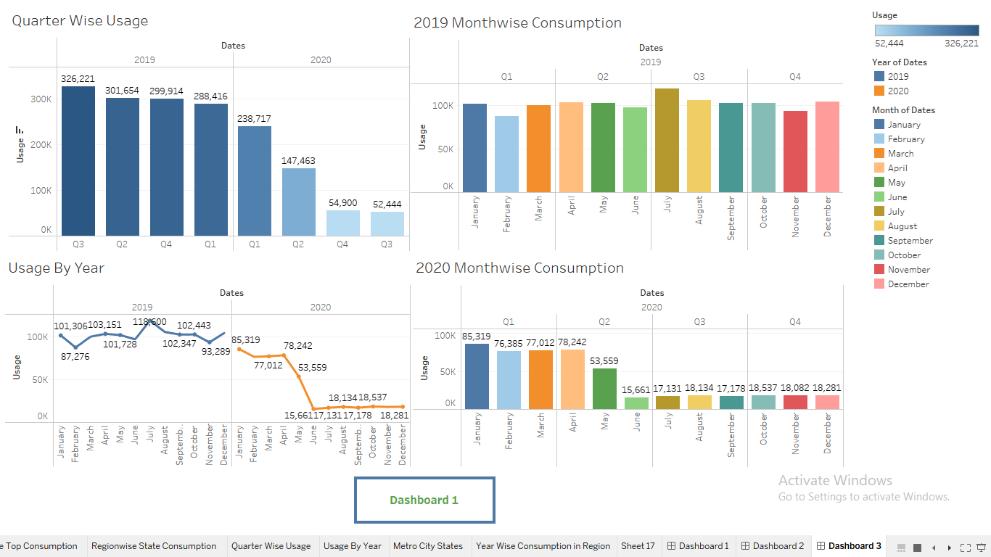

# STORY

# 1.

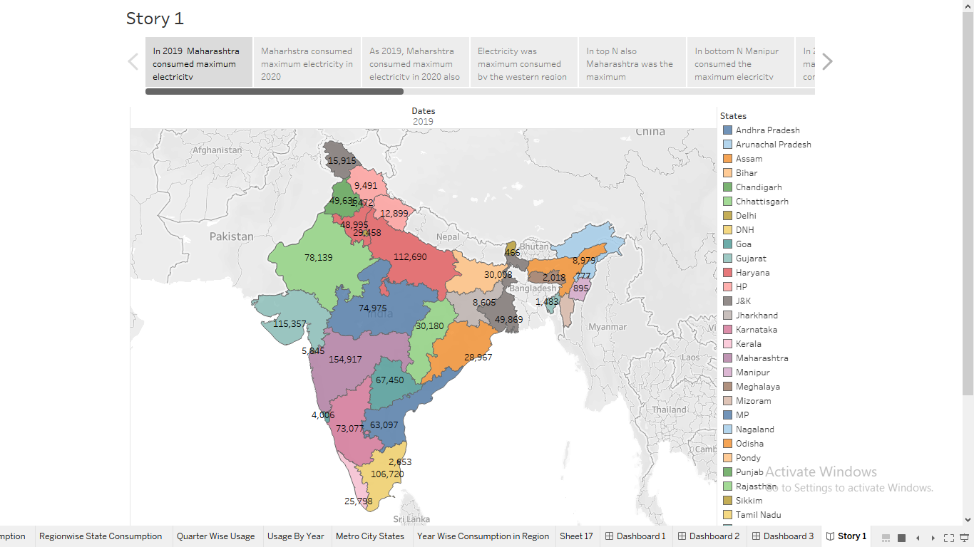

# 2.

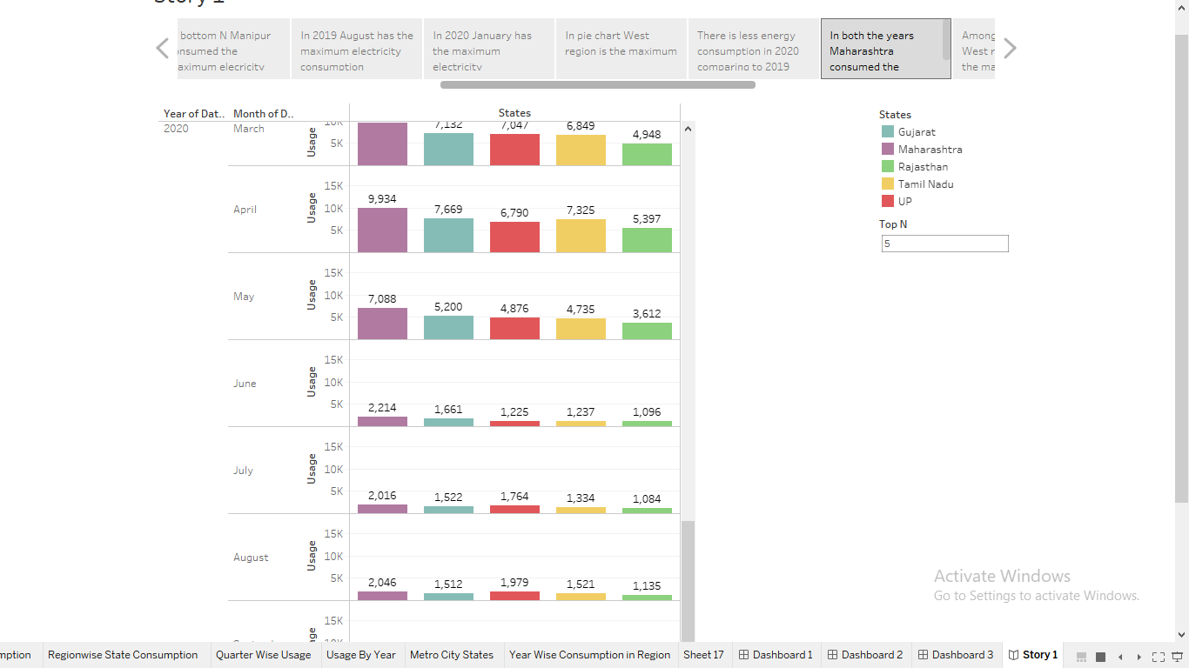

# 3.

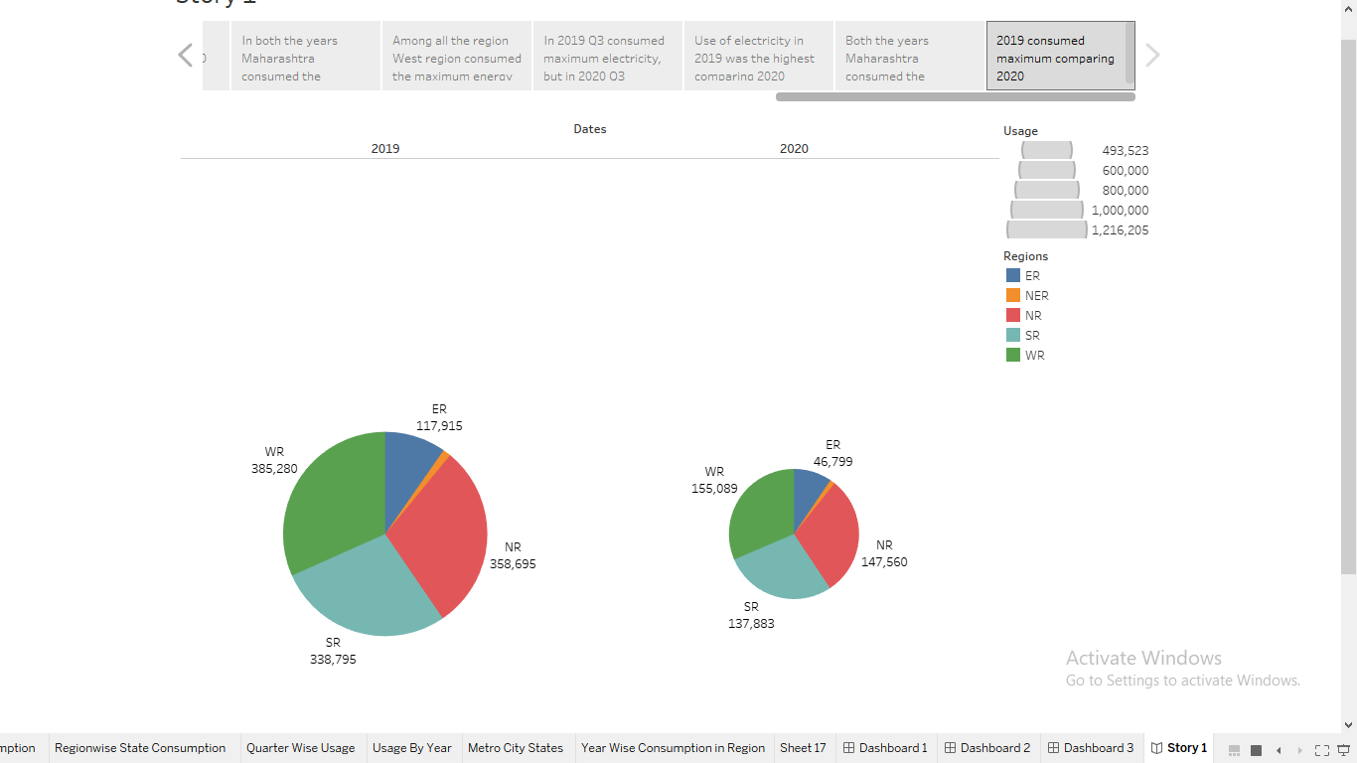

# 4.ADVANTAGES OF ELECTRICITY CONSUMPTION ANALYSIS

The advantages of analysis of electricity consumption is used to solve the problems of low overall service quality of the University Computer room , unstable environment control of the computers room , low adaptive adjustment ability and high energy consumption . The above visualizations are helpful to identify the consumption of electricity in different regions of India .

Electricity is an essential part of modern life . People use electricity for lighting , heating , cooling , and refrigeration and for operating appliances , computers , electronics, machinery and public transportation systems.

The electricity consumption and charges of the network computer room of Chengde Petroleum College before and after the system was used in 2020-2021, as shown in Table 9. Comparative data shows that the computer room's power consumption from January to December 2021 will be reduced by 15% to 27% every month compared with the same period in 2020. Table 10 compares the energy consumption monitoring of the traditional university network computer room and the energy consumption monitoring of the university computer room based on the Internet of Things and edge technology. The computer room energy consumption monitoring system based on the Internet of Things and edge computing technology has energysaving, energy-saving, and emission reduction effects, equipment safety analysis, data standardization, operation and maintenance costs, and monitoring objects.

# 5. APPLICATIONS

Analyzing the data can help in understanding the user’s electricity consumption behavior and demands , thus enabling better service to be provided to them .

First, principle component analysis is used to reduce the dimensions of data . Subsequently , the single clustering method is used and majority is selected for integrated clustering.

The applications of electricity consumption and its energy use in home , water heaters , refeigerators , television , dishwasher etc .

The largest electricity consumer in the average household is your **heating and cooling appliance**. By a long shot. Central air conditioners and heaters use tons of energy in order to keep your home set to the right temperature.

Electricity is **a form of energy that can gives things the ability to move and work**. It is the flow of tiny particles called electrons. Thus, electricity is the form of energy that we get when electrons flow from one place to another.

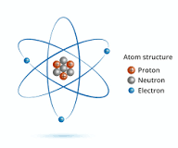

# 6.CONCLUSION

The goal of data visualization is interesting one . It is more accessible and easier to interpret makes the data visuable to others and get insights from it .

The purpose of this study is to explore the pattern of electricity consumption and energy loss to highlight the strengths and weakness of energy efficiency . The energy consumption pattern has an inverse relation with the population distribution , family size and building characteristies in the city . This is clearly identified by addressing the downtown region that has the lowest energy consumption and highest- density population .

 Energy conservation is the effort made by us to reduce the consumption of energy by using less of an energy service or using reneuable energy .

Electric energy consumption is **energy consumption in the form of electrical energy**. About a fifth of global energy is consumed as electricity: for residential, industrial, commercial, transportation and other purposes.

The supply of energy on Earth is not infinite. Furthermore, **it can take a long time to regenerate energy**. This makes energy conservation even more important.

# 7. FUTURE SCOPE

Prior to the global pandemic , India’s energy demand was projected to increase by almost 50% between 2019 and 2020 , but growth over this period is now closer to 35 % in the STEPS and 25% in the Delayed Recovery Scenario .

In the Stated Policies Scenario , global electricity demand grows at 2.1% per year to 2040, twice the rate of primary energy demand Electricity demand growth is set to be particularly strong in developing economics . India’s electricity demand is still projected to grow by almost 5% per year to 2040in the STEPS , which is nearly double the rate of energy demand as a whole .

The prediction of energy consumption in 2050. By 2050 renewable energy consumption is expected to increase and will reach about 247 hexa joules .

The Indian power sector is forecasted to attract investments worth $128.24-135.37 Bn between FY19-23. The future of the sector looks bright since **by 2026-27 the country's power generation installed capacity will close to 620 GW, of which 38 % will be from coal and 44% from renewable energy sources**.

Energy systems can range in scope, from **local, municipal, national, and regional, to global**, depending on issues under investigation. Researchers may or may not include demand side measures within their definition of an energy system.